# **Clostridium (Anaerobic Spore-Forming Gram-Positive Rods)**

**Characteristics:** *Clostridium* (and the reclassified *Clostridioides*) are **obligate anaerobes** that form spores. They are Gram-positive rods (though older cells can stain Gram-negative) and **catalase negative**. They differ from Bacillus by being anaerobic. Many *Clostridium* species are normal flora of the gut or environment, but some cause serious diseases via toxins (tetanus, botulism, gas gangrene, C. diff infection).

**Major Clostridium and Identification Clues:**

**Clostridium perfringens:**

* Causes gas gangrene and food poisoning.
* **Boxcar arrangement**
* **non-motile** (unique among clostridia, which are typically motile).
* On anaerobic blood agar, it produces **double-zone β-hemolysis** (an inner clear zone by theta toxin and outer hazy zone by alpha toxin).
* It is **lecithinase positive** on egg yolk agar (opaque precipitate due to alpha toxin/phospholipase).
* Nagler reaction (neutralization of lecithinase with antitoxin on egg yolk agar) can specifically identify *C. perfringens* by inhibiting the opacity.
* It ferments many sugars and produces abundant gas in tissue (hence gas gangrene).
* A **reverse CAMP test** with *C. perfringens* and *Group B strep* shows enhanced hemolysis between the streaks (the opposite setup of the usual CAMP).
* indole negative

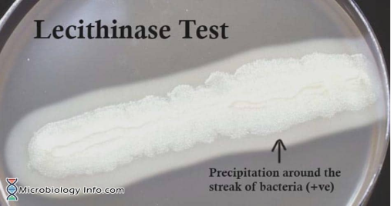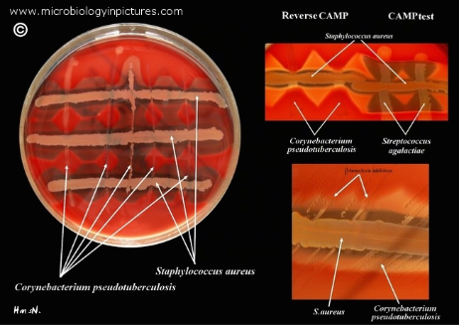

**Clostridioides (Clostridium) difficile:**

* Causes antibiotic-associated diarrhea and pseudomembranous colitis.
* It is an anaerobic rod with subterminal spores (drumstick appearance on Gram stain).
* Colonies on selective cycloserine-cefoxitin-fructose agar (CCFA) are yellow (ferments fructose)
* smell of horse manure.
* **produces toxins (A and B)** detected by immunoassays or molecular tests. Identification in practice is by detecting toxin or gene (e.g. PCR for toxin B gene) rather than extensive biochemical tests.
* fluoresce **chartreuse (yellow-green)** under UV light.
* **indole negative**

**Clostridium tetani:** Causes tetanus.

* **C. tetani → Tetanus:** Painful spasms with **trismus (lockjaw)**, **risus sardonicus**, and **opisthotonos**, usually after a contaminated wound; generalized disease predominates and may cause autonomic instability.
* A slender rod with a **terminal spore** giving a classic “drumstick” or tennis racket appearance.
* Extremely oxygen-sensitive.
* On blood agar, *C. tetani* colonies often swarm over the plate (thin film growth) and are β-hemolytic.
* **indole positive**.
* Identification is usually clinical (characteristic symptoms), and laboratory isolation is rare; when isolated, the appearance and swarming motility are indicative.
* There is no rapid biochemical kit for *C. tetani* in routine labs due to its high safety risk (handled in anaerobic conditions). -

**Clostridium botulinum:**

* **C. botulinum → Botulism:** **Symmetric, descending flaccid paralysis** with early cranial nerve palsies (diplopia, dysphagia, dysarthria), dry mouth, and constipation; forms include foodborne (adults), infant “floppy baby,” wound botulism, and IVDU.
* Causes botulism.
* Morphologically similar to *C. tetani* (can have subterminal spores).
* On egg yolk media, some strains show **lipase positive** (an iridescent sheen on egg yolk agar) and are **lecithinase negative**.
* Identification is typically by toxin detection (mouse bioassay or PCR for toxin genes) rather than by routine culture, except in reference labs.

**Clostridium sporogenes** and other putrefactive clostridia: These are often **motile** and **proteolytic** (causing odor). *C. sporogenes* is biochemically similar to *C. botulinum Group I (proteolytic)* but non-toxigenic. They produce a strong foul odor and are indole variable.

**Clostridium septicum:**

* Associated with gas gangrene especially in neutropenic patients or with colon cancer (indicative organism).
* It is motile, β-hemolytic, and spreads (swarming) on agar.
* *C. septicum* is often **indole negative** and ferments some sugars but not lactose.

**Other clostridia:** *Clostridium sordellii* (causes gas gangrene, notable for causing toxic shock syndrome in some cases) is **urease positive** and **motile**, with a peculiar colony smell. *Clostridium bifermentans, Clostridium tertium* (which can aerotolerate), etc., each have some differentiating tests, but in an exam setting, focus is on the major ones above.

**Identification Strategy:** For anaerobic Gram-positive rods, consider these steps: -

1. Check **aerotolerance >** Ensure it’s truly anaerobic (no growth aerobically).
2. Observe **colony morphology and hemolysis** on anaerobic blood agar: - **Double zone hemolysis** suspect *C. perfringens*.
3. Verify with **lecithinase test** or on egg yolk agar or negative cAMP test (positive for *C. perfringens*).
4. **Swarming motility** or spreading colonies motile clostridia like *C. septicum, C. tetani, C. sporogenes*. - **Nonhemolytic, horse-manure odor, chartreuse fluorescence** suspect *C. difficile* (confirm with toxin test).
5. Perform key biochemicals if needed: - **Lecithinase vs Lipase on Egg Yolk Agar:** 
   * *C. perfringens* = lecithinase +, lipase –
   * *C. botulinum (some strains)* = lecithinase –, lipase +;
   * *C. sporogenes* = lipase +;
   * *C. septicum* = usually neither.
   * **Indole test:** *C. tetani* (indole +), *C. sporogenes* (+), most others –.
   * **Urease:** *C. sordellii* is urease + (most clostridia are urease negative).
   * **Toxin assays:** For *C. difficile*, *C. botulinum*, and *C. tetani*, detection of toxin is the gold standard. In a routine lab, any isolate suspected to be *C. tetani* or *C. botulinum* would be referred for toxin testing and definitive ID.

**Safety:** *Clostridium* identification often requires handling of toxigenic organisms under safe conditions. The lab should be cautious with *C. tetani* and *C. botulinum* (do not attempt toxin production in standard labs). *C. difficile* requires careful containment due to spores. For exam purposes, recognizing classic test results (like *C. perfringens* being non-motile, double-zone hemolytic) and unique characteristics (drumstick spores of tetanus, chartreuse fluorescence of *C. diff*) is key.